Shabbos Stories for
Parshas pinchas 5775
Volume 6, Issue 44 24 Tammuz 5775/ July 11, 2015
Printed L’illuy nishmas Nechama bas R’ Noach, a”h

For a free subscription, please forward your request to keren18@juno.com

Man Saved from a Chandelier Tragedy Because of Birchas Hamazon and Zimun

A fascinating story has emerged from the tragedy that occurred last week [June 22nd] at the Adia banquet hall in Yavneh, where a large chandelier fell and caused the injury of dozens of guests and the death of one.
Days after the disaster, the story of Yakir Guetta was revealed. During the wedding, Yakir wanted to go to the bar of the hall, but he decided to first recite Birchas Hamazon. During that moment, the lighting fixture crashed into the bar area, wreaking havoc.
Yakir shared his story, relating that he was at the event with his mother and two brothers.
He said that before going to the bar, he told his brothers that they should make a zimun – recited when three men eat together – and bentch before leaving their table.
“As soon as we finished Birchas Hamazon,” he related, “we saw that the bar had become a death trap with what became a terrible tragedy. And it all happened meters away, right where we would have been had we gone to the bar.”
Yakir added another aspect to his story: “At this point, my brother’s wife [who was not at the event] woke up in a panic after she dreamed that she was at his funeral. She called to see how he was doing” before she had heard about the tragedy.
“I do not understand the miracles or the calculations of Heaven,” he said. “I just know that it appears that we were given our lives as a gift.”
Yakir explained the reason he revealed his story: “I wish to let people know that I am not someone great or even an avreich. I am a sinner and do not always obey the mitzvos. I’m just a simple person who kept one little mitzvah, deciding to say thank you [to Hashem] for the food I ate.”
“Az todah al hamazon v’al hamichyah - So thanks for the food and for my life,” concluded Yakir.

Reprinted from the June 29, 2015 edition of Matzav.com (Israel News Bureau)

It Once Happened

The Chida and the Kotel

The Western Wall, the Kotel, is the one remaining wall of the great walls that surrounded the Holy Temple. Its name refers to the fact that it stood on the western side of the Temple.
When the Temple was destroyed, G-d swore that this part of the wall would remain forever. Our Sages say that the Divine Presence never leaves this holy site. For this reason, the Kotel has become the national spiritual focal point.
Tens of thousands of Jews have undertaken pilgrimages to Jerusalem throughout the centuries, even when it was very dangerous, in order to stand before G-d in prayer at this holiest place. The tradition has been passed down that no prayer offered at this most sanctified spot goes unanswered.
The Kotel consists of four layers of stones, dating from different time periods and constructed in different styles. The lowest level consists of the largest stones, which date back to the first Temple of King Solomon. The largest stones are actually several meters high, one even calculated to weigh 400 tons!
The second level of stones dates to the time of the Second Temple. The third level was laid 700 years ago. The highest seventeen upper rows, which consist of much smaller stones, were laid only about a hundred years ago by Sir Moses Montefiore.
Architects and engineers are puzzled as to how the huge blocks of stone were quarried and brought to the site without modern methods of transportation.
Our Sages, however, have given the answer: The enormous stones were borne aloft and laid one on top of the other in a miraculous fashion.

The great tzadik, Rabbi Chaim ben Attar, known as the Ohr Hachayim (HaKadosh), after his work of the same name, had many remarkable students. One of them was Rabbi Chaim Yosef David Azulai, who is known by the acronym of his name, the Chida.
When the Chida went to live in Israel his teacher gave him, as is the time-honored custom, a note to insert between the stones of the Kotel. The Chida took the note, put it in a safe place, and resolved to follow his master's bidding as soon as he arrived in the Holy Land.
When he arrived in Israel, the Chida decided that rather than depend on charity of any kind, he would work by the sweat of his brow. To implement his plan, he bought a donkey and a wagon and set about earning his meager subsistence as a hauler of clay.
He lived in this way for the first few years, satisfied that he was managing through his own efforts, and avoiding accepting charity. Then, suddenly his donkey died, leaving him with no means of support.
The Chida was crushed by this unforeseen turn of events, and as Torah teaches us, he searched into his actions trying to discover the reason for his suffering this calamity. Then he realized: the note! He had completely forgotten about it. The Chida first immersed himself in a mikva. Then he hurriedly found the paper on which the Ohr Hachayim had written his message, and rushed with it to the Kotel.
Once there, he inserted it, unread, into the deep crevices of the ancient stones. He immersed himself in prayer, asking the forgiveness of his teacher. Feeling much relieved, the Chida returned to his usual place in the study hall. But something was different.
People were looking at him with different gazes than before and treating him with great deference and almost fear, as if he was a notable personage. "What has happened that you are behaving in this strange manner towards me?" he asked them.
But the people themselves couldn't explain what it was about him that provoked their reaction. "Maybe you can tell us what is different about you today," they replied.
With that, the Chida told them about his misfortune, which he regarded as a punishment for his forgetting about the note he had forgotten about for so long.
He explained to them that today he had at last completed his task and obeyed the Ohr Hachayim by placing the note in the stones of the Kotel.
When the scholars of the study hall and the heads of the community heard this story, they were very curious to know what was written on the note.
Invoking all their authority, they implored the Chida to show them where he had placed the note. He took them to the exact spot at the Kotel where the note lay.
They took it out and opened it. The message on the note read, "My sister, my bride [mystical references to the Divine Presence which rests at the Kotel] I beg you to help my beloved student in his time of need."
When word spread around Jerusalem of this wondrous story the people understood the greatness of the Chida and decided to appoint him Chief Rabbi of the Holy City.

Reprinted from this week’s (Parhas Pinchas) edition of “L’Chaim Weekly,” a publication of the Lubavitch Youth Organization in Brooklyn, NY.

Story of the Week

The Non-Observant Jewish Woman Who Didn’t
Want to Eat Kosher Food in the Nursing Home

Rav Noach Weinberg, of blessed memory, tells the story of a person who owned a nursing home. In the nursing home, 90% of the residents were non-Jews. He served them non-kosher meat. However, he had three or four residents who were non-observant Jews.
As the Jewish Law requires, he would not serve these Jewish residents non-kosher food. He prepared special kosher meals for them. One day the State Inspector came to inspect the nursing home.
One of those Jewish residents, an old woman, complained to the inspector that her food was not as good as everyone else's food. The inspector investigated and found out that there were in fact two menus. The inspector gave the owner of the home an ultimatum: "Either you acquiesce and give this woman the food she wants or I will shut down your home."
The owner went to the woman and told her that kosher meat was better and healthier and more expensive than non-kosher meat. None of his reasoned arguments made a difference. The woman was adamant, and insisted she wanted the non-kosher meat.
Finally, he began talking to the woman about Judaism. He told her that she would soon be meeting her Maker. He explained the concepts of reward and punishment in the afterlife to her. To make a long story short, he was successful, and she told the inspector she wanted the kosher meat.
Rav Weinberg asked the nursing home operator how he was successful in reaching and convincing this woman who was so set in her ways and who for so long had rejected Torah practices to suddenly say she wanted to only eat kosher. The nursing home operator told him simply, "You don't understand. I HAD TO DO IT. If not, I would have lost my business."

Comment: When there’s a will, with G-d’s help, there’s a way!

Quote of the Week
“It is easier to prevent bad habits than to break them.” (Benjamin Franklin)

Once a person becomes accustomed to a certain transgression, our Sages teach, it becomes permissible to him. How important it is for us to withhold when tempted and not give bad habits resident status.

Reprinted from last week’s email of Mendel Berlin’s IVORT.

A Slice of Life

Do a Favor for Another
By Rabbi Shlomo Zalman Levkivker

One year on Simchat Torah, I walked to the Lantzuter shul (synagogue) in Williamsburg, Brooklyn, with a number of other Lubavitcher Chasidim in fulfillment of the Rebbe's directive to bring the joy of the holiday to Jews in other neighborhoods.
After sharing some teachings of the Rebbe and dancing with the congregants in celebration of Simchat Torah, we prepared to leave and walk back to Crown Heights. One of the shul's elder Chasidim asked us to wait. "I want to tell you a unique story," he said. Naturally, we remained to listen.
"Once, in the 1950s," the elder Chasid began, "two yeshiva students from Crown Heights came to this synagogue on Simchat Torah. I was then just a young boy. My father, of blessed memory, was the synagogue's sexton, and the students went up to him and asked if they could speak. My father told them that they had to ask the rabbi. The students wasted no time, and they went straight up the Lantzuter Rav. The Lantzuter Rav happily agreed to let the students share the teachings of the Lubavitcher Rebbe.
"Afterwards, the Lantzuter Rav shared with my father and a number of others, a personal story he had with the Previous Lubavitcher Rebbe, Rabbi Yosef Yitzchak Schneersohn. I listened to the story, as well.
"The Lantzuter Rav began, 'Prior to the Second World War, there was a large and vibrant Jewish community in the city of Lantzut, located in southeastern Poland. Several thousand Jews lived in the city before the eve of Rosh Hashana, 1938, when Lantzut was occupied by the Nazis (may their name be erased). Ten days later, on Yom Kippur, the entire Jewish population, myself included, was expelled for allegedly being Communists. We were driven into Soviet occupied territory towards the San River.
"A stranger in a strange land, I began to wander from place to place, looking for somewhere I could rest from my weary journey. Then one day, I was stopped by the Soviet authorities. Since I had no identification documents and I couldn't speak Russian, I was placed under arrest. After a hasty trial, I was exiled to the frozen wastelands of Siberia.
"However, my hardships didn't end in Siberia,' the Lantzuter Rav continued. 'Libelous charges were lodged against me that I had passed secret information to the Poles. This amounted to sedition against the U.S.S.R., and if convicted, I could be sentenced to death, G-d forbid! In fact, 12 people had testified to my guilt! Furthermore, since I was a rabbi, the case aroused a great deal of interest, and many people came for the "trial," the results of which were determined well in advance.
"Under normal circumstances, there was no chance for me to survive such proceedings. Yet, I experienced a miracle. After the 'witnesses' completed their testimony, the judge pounded his gavel, turned me and said, 'You are charged with violating Statute #... The fact that you show ingratitude for Mother Russia, paying her with evil for the good she has done for you, after welcoming you with open arms from the fires of Poland, and your willingness to assist the enemies of the Soviet people - all this pales in comparison to your greatest crime. You are a "rabbiner," a Jew, and it is written in your Torah, "Pray for the welfare of the government." Therefore, as a "rabbiner," how can you possibly act contrary to your Torah and commit treason against your country?'
"'Your Honor is correct,' I replied to the judge. 'I am a practicing rabbi, and our Torah condemns such conduct. However, it never crossed my mind for a moment to offer aid and comfort to our country's enemies. All the testimony brought against me by these witnesses is completely false. I have never committed treason against Russia and I never will,' I emphatically declared.
"To my great astonishment, the judge accepted my plea. He rapped his gavel again, declared that he had found me innocent of all charges, and ordered my immediate release!
"I was stunned. Never in my wildest dreams did I imagine that I would be set free. When the hall emptied and I left the courtroom, the judge approached me and placed a note in my hand. He had written that he wanted to see me in his home - at eleven p.m.
"I came to the judge's house at the appointed time. The judge welcomed me with great respect. He then offered me a seat in his living room and proceeded to tell me what had impelled him to clear me of all charges.
"The judge began, "Just before I was drafted into the Red Army, I went to the Lubavitcher Rebbe, Rabbi Yosef Yitzchak Schneersohn, to receive his blessing. The Rebbe looked at me with his holy eyes, and said to me cryptically: 'When you reach a position of greatness - don't forget to do a favor for another Jew." '
"The years passed. In the army I was quickly promoted. After my discharge, having proven my loyalty to Russia, I received high-ranking positions with the local Ministry of Justice, eventually being appointed to serve as a judge. When you arrived in the hall, my eyes began to dim. I saw the rows of witnesses before me, and I realized that if I would dare to try to rue in your favor, the people in the courtroom would tear us apart. I was about to render my decision in accordance with Soviet law, when I suddenly envisioned my holy audience with the Rebbe from years ago. I again saw the Lubavitcher Rebbe, Rabbi Yosef Yitzchak, looking at me with piercing eyes and saying to me, 'When you reach a position of greatness - don't forget to do a favor for another Jew.'
"I decided then and there that no matter what happened, I would risk my life to exonerate you. G-d Alm-ghty helped and He placed the right words into my mind, which thank G-d, resulted in your acquittal and our both leaving the courtroom, safe and sound..."

Reprinted from the Parshas Chukas 5775 edition of “L’Chaim Weekly,” a publication of the Lubavitch Youth Organization in Brooklyn, NY. This article originally appeared in Beis Moshiach Magazine

Love of the Land

Zion Gate – The Big Key

When Rabbi Mordechai Weingarten heard a knock at the door of his home in the courtyard of the Ohr HaChaim Synagogue in the Old City of Jerusalem he could hardly have imagined who was seeking entry.
As the last official muchtar, district head, of the Old City, he was the liaison between the British Mandate officials and the Jews. As the British evacuated the Walled City, a British officer had come to present the rabbi with an old, rusty, foot-long key to Zion gate, as a gift from England to the Jewish People.

Reprinted from last week’s email of OHRNET, the Ohr Somayach Torah Magazine of the Internet.

L’Maaseh…A Tale to Remember

Farmer or Singer?

Rav Ephraim Wachsman told a powerful story when he spoke to a large group of boys in camp one summer. It says in Pirkei Avos, “Kol Yisroel Yeish Lahem Cheilek L’Olam Haba, Every person in Klal Yisroel has a portion in the World to Come”.
Rav Wachsman said that beyond the simple meaning, the verse teaches that “Every person in Klal Yisroel has a portion (Cheilek) that no one else in the world has or will ever have for the rest of eternity.”
He explained his thoughts with a parable: There once was a poor farmer boy whose father put him to work caring for the cattle and sheep. Each morning, the boy would milk the cows and take the animals out to the fields to graze. As he sat high in the mountains keeping a watchful eye on the flock, he would pass the time by singing beautiful songs.
One day, a passerby on the road overheard the boy’s singing. Entranced by the beauty of his voice, he climbed to the spot where the boy was sitting and greeted him.
“My child,” he said, “what are you doing here on this farm? You have such a wonderful voice! You could be making millions of dollars and delighting the world with such a special voice!”
The boy was clearly flattered, but he could not believe that his talent was at all extraordinary. Nevertheless, the man persisted with his visions for the boy’s future. “Let’s go talk to your father about this,” he suggested.
The boy and the man left the fields and found the boy’s father. The man explained that he was certain that this boy could become a great singer whose voice would inspire the world.
“This isn’t for us,” the father said firmly. “He’s got a nice voice, but so what? I’m a farmer, my father was a farmer, and his father was a farmer. Now my son has learned to be a farmer. He belongs here with me.”
The man insisted that such talent couldn’t be wasted. “You don’t have to believe me,” he told the father. “I have a friend who is one of the greatest names in music. Come with me to see him and we will let him judge your son’s talent.” After some persuading, the father agreed.
They brought the boy to the musician, who asked the boy to sing his favorite song. For a few minutes, the room filled with the sweetest, most melodious sounds the musician had ever heard. Then the song came to an end.
“My boy, you have the most beautiful voice I have ever heard in my entire life! I have heard hundreds of singers, but none with a voice equal to yours! Not only that, but I believe there has never been a boy with such a voice, and I don’t believe there ever will be another like you. You are going to be very rich and famous one day!”
The father, who until now had remained silent, cried out, “Enough! I have heard enough of this talk about singing. Come son, we are leaving.”
“But sir, don’t you realize what a talent you have here?” the musician pleaded. “You are not just depriving him. You are depriving the world!”
“I have made up my mind. My grandfather was a farmer, my father was a farmer, and I am a farmer. My son is a farmer and that is what he will remain!”
Rav Wachsman explains that each of us has greatness inside of us. Our neshamos are sent into this world with the talents and skills they need to create our own masterpiece of Torah and Mitzvos.
The tragedy is when, like the singer, we do not seek the opportunity to develop the gifts Hashem has given us! If we don’t use our gifts from Hashem— the talents and skills that we have, who will use them?

Reprinted from last week’s email of Torah U’Tefilah: A Collection of Inspiring Insights compiled by Rabbi Yehuda Winzelberg.

Nicholas Winton, Rescuer of 669 Children From Holocaust, Dies at 106

By Robert D. McFadden

Nicholas Winton, a Briton who said nothing for a half-century about his role in organizing the escape of 669 mostly Jewish children from Czechoslovakia on the eve of World War II, a righteous deed like those of Oskar Schindler and Raoul Wallenberg, died on Wednesday [July 1st] in Maidenhead, England. He was 106.
The Rotary Club of Maidenhead, of which Mr. Winton was a former president, announced his death on its website. He lived in Maidenhead, west of London.
It was only after Mr. Winton’s wife found a scrapbook in the attic of their home in 1988 — a dusty record of names, pictures and documents detailing a story of redemption from the Holocaust — that he spoke of his all-but-forgotten work in the deliverance of children who, like the parents who gave them up to save their lives, were destined for Nazi concentration camps and extermination.
For all his ensuing honors and accolades in books and films, Mr. Winton was a reluctant hero, often compared to Schindler, the ethnic German who saved 1,200 Jews by employing them in his enamelware and munitions factories in Poland and Czechoslovakia, and to Wallenberg, the Swedish businessman and diplomat who used illegal passports and legation hideaways to save tens of thousands of Jews in Nazi-occupied Hungary.

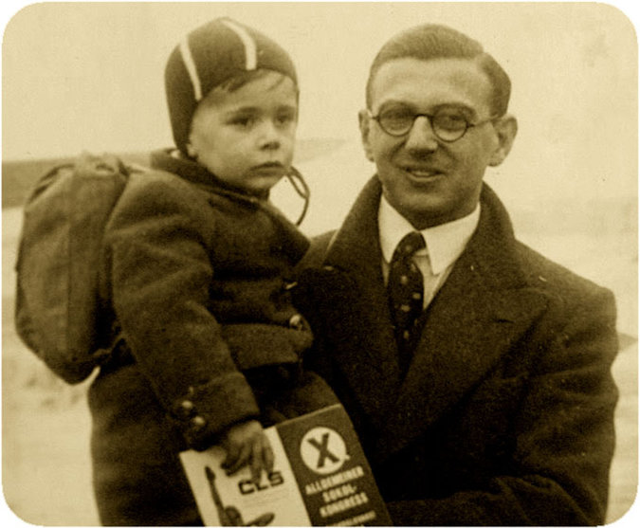
A family picture of Nicholas Winton with one of the hundreds of Jewish children whose lives he saved during World War II. CreditPress Association, via Associated Press

Mr. Winton — Sir Nicholas in England since 2003, when he was knighted by Queen Elizabeth II — was a London stockbroker in December 1938 when, on an impulse, he canceled a Swiss skiing vacation and flew to Prague at the behest of a friend who was aiding refugees in the Sudetenland, the western region of Czechoslovakia that had just been annexed by Germany.
“Don’t bother to bring your skis,” the friend, Martin Blake, advised in a phone call.
Mr. Winton found vast camps of refugees living in appalling conditions. The pogroms of Kristallnacht, the “Night of Broken Glass,” had recently struck Jewish shops, homes and synagogues in Germany and Austria. War looked inevitable, and escape, especially for children, seemed hopeless, given the restrictions against Jewish immigration in the West.

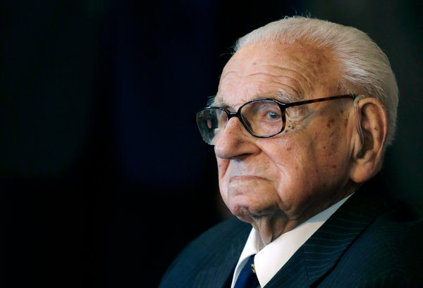
Nicholas Winton in 2014. Credit David Josek/Associated Press

Britain, however, was an exception. In late 1938, it began a program, called Kindertransport, to admit unaccompanied Jewish children up to age 17 if they had a host family, with the offer of a 50-pound warranty for an eventual return ticket. The Refugee Children’s Movement in Britain sent representatives to Germany and Austria, and 10,000 Jewish children were saved before the war began.
But there was no comparable mass-rescue effort in Czechoslovakia. Mr. Winton created one. It involved dangers, bribes, forgery, secret contacts with the Gestapo, nine railroad trains, an avalanche of paperwork and a lot of money. Nazi agents started following him. In his Prague hotel room, he met terrified parents desperate to get their children to safety, although it meant surrendering them to strangers in a foreign land.
As their numbers grew, a storefront office was opened. Long lines attracted Gestapo attention. Perilous confrontations were resolved with bribes. Eventually he registered more than 900 children, although he had names and details on 5,000. In early 1939, he left two friends, Trevor Chadwick and Bill Barazetti, in charge in Prague and returned to London to find foster homes, raise money and arrange transportation.

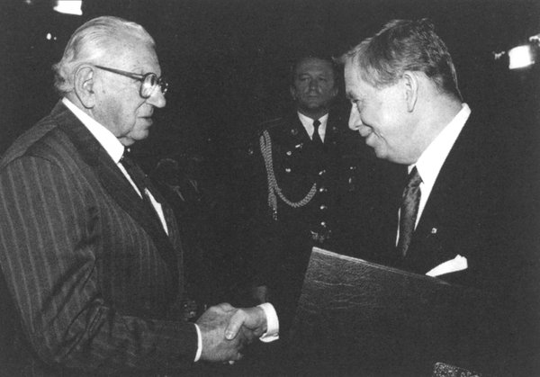
Mr. Winton received the Czech Republic’s highest honor from President Vaclav Havel in 1998.Credit"Nicholas Winton and the Rescued Generation"

He and a few volunteers, including his mother, calling themselves the British Committee for Refugees from Czechoslovakia, Children’s Section, enlisted aid from the Refugee Children’s Movement, had photos of the children printed and appealed for funds and foster homes in newspaper ads and church and synagogue bulletins.
Hundreds of families volunteered to take children, and money trickled in from donors — not enough to cover all the costs, but Mr. Winton made up the difference himself. He also appealed to the Home Office for entry visas, but the response was slow and time was short. “This was a few months before the war broke out,” he recalled. “So we forged the Home Office entry permits.”
In Prague, Mr. Chadwick quietly cultivated the chief of the Gestapo, Karl Bömelburg — they called him “the criminal rat” after his inspector’s rank of kriminalrat — and arranged for forged transit papers and bribes to be passed to key Nazis and Czech railway officials, who threatened to halt trains or seize the children unless they were paid off. The Gestapo chief proved instrumental, clearing the trains and transit papers, Mr. Chadwick said.

Searing Separations
Mr. Winton sent more money, some for bribes and some to cover expenses for children whose parents had been arrested and shot or had fled into hiding, while many of the Czech families sold possessions to pay for their children’s escape. The red tape and paperwork seemed endless.
But on March 14, 1939, it all came together. Hours before Hitler dismembered the Czech provinces of Bohemia and Moravia as a German “Protectorate,” the first 20 children left Prague on a train. Survivors told of searing scenes on the station platform in the final moments before departure as children sobbed and pleaded not to be sent away and parents faced giving up their children.
Mr. Winton and his colleagues later arranged for eight more trains to get the rest of the children out, crossing the Third Reich through Nuremberg and Cologne to the Hook of Holland, then across the North Sea by boat to Harwich, Essex, and on by British rail to the Liverpool Street Station in London. There, he and the host families met the children. Each refugee had a small bag and wore a name tag.
But on March 14, 1939, it all came together. Hours before Hitler dismembered the Czech provinces of Bohemia and Moravia as a German “Protectorate,” the first 20 children left Prague on a train. Survivors told of searing scenes on the station platform in the final moments before departure as children sobbed and pleaded not to be sent away and parents faced giving up their children.
Mr. Winton and his colleagues later arranged for eight more trains to get the rest of the children out, crossing the Third Reich through Nuremberg and Cologne to the Hook of Holland, then across the North Sea by boat to Harwich, Essex, and on by British rail to the Liverpool Street Station in London. There, he and the host families met the children. Each refugee had a small bag and wore a name tag.
But only seven of the eight trains made it through, the last in early August, bringing the total rescued to 669. About 250 children, the largest group, were on board the last train out, on Sept. 1, 1939. On that day, however, Hitler invaded Poland, all borders controlled by Germany were closed and Mr. Winton’s rescue efforts came to an end.
“Within hours of the announcement, the train disappeared,” he recalled. “None of the 250 children aboard was ever seen again.” All were believed to have perished in concentration camps.
Nearly all the saved children were orphans by war’s end, their parents killed at Auschwitz, Bergen-Belsen or Theresienstadt. After the war, many remained in Britain, but others returned to Czechoslovakia or emigrated to Israel, Australia or the United States. The survivors, many now in their 70s and 80s, still call themselves “Winton’s Children.”

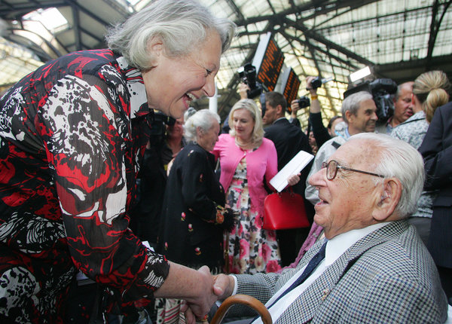
Nicholas Winton is greeted by a woman who was one of the 669 mostly Jewish children that he helped to escape Nazi-occupied Czechoslovakia in 1939. A Briton, he kept silent about his role in organizing the evacuations for 50 years, until his wife found a scrapbook in the attic. CreditGeoff Caddick/Agence France-Presse — Getty Images

After finding his long-hidden scrapbook — crammed with names, pictures, letters from families, travel documents and notes crediting his colleagues — his wife asked for an explanation. He gave her a general idea, but said he thought the papers had no value and suggested discarding them.
“You can’t throw those papers away,” she responded. “They are children’s lives.”
“I did not think for one moment that they would be of interest to anyone so long after it happened,” Mr. Winton recalled later.
But he reluctantly agreed to let her explore the matter. She gave the scrapbook to a Holocaust historian. A newspaper article followed. Then a BBC television program featured the story of his rescues, and the publicity went worldwide.
He was showered with encomiums: the Czech Republic’s highest award, honorary citizenship of Prague, an American congressional resolution, letters of appreciation from President George W. Bush, Prime Minister Tony Blair of Britain, former President Ezer Weizman of Israel and people around the world, and a nomination by the Czech Republic for the Nobel Peace Prize. His scrapbook went to Yad Vashem, the Holocaust memorial in Israel. Streets and schools were named for him. Statues went up in Prague and London.

Incredulous at Fame
Why did he do it?
He never really explained, though he offered a bare rationale in an interview with The New York Times in 2001: “One saw the problem there, that a lot of these children were in danger, and you had to get them to what was called a safe haven, and there was no organization to do that. Why did I do it? Why do people do different things? Some people revel in taking risks, and some go through life taking no risks at all.”
Ms. Gissing, in her book “Nicholas Winton and the Rescued Generation: Save One Life, Save the World” (2001, with Muriel Emanuel), said Mr. Winton was incredulous at his fame. “Winton still shakes his head in bewilderment and disbelief when compared with Oskar Schindler and Raoul Wallenberg,” she wrote. “I try to make him realize that his contribution to the human race is immeasurable.”
The rescues were explored in three films by the Slovak director Matej Minác: the fictionalized “All My Loved Ones” (1999); a documentary, “The Power of Good: Nicholas Winton” (2002); and “Nicky’s Family” (2011), and in Mr. Minác’s book, “Nicholas Winton’s Lottery of Life” (2007).
On Sept. 1, 2009, 70 years after the onset of the war halted the rescue operations, a special train with a locomotive and carriages from the 1930s left Prague to re-create the perilous 1939 journeys. On board were some of the original Winton’s Children and many of their descendants, whose numbers now exceed 6,000.
They were met at Liverpool Street Station by Mr. Winton, who had recently turned 100.

Reprinted from the July 2, 2015 edition of The New York Times. Al pi halacha, Mr.Winton was born a Jew and a Jew he died. Is it any secret that the pintele Yid in him expressed itself in his unusual efforts to help save innocent but endangered Jewish children in Czechoslovakia.

